**WEB DESIGN/DEVELOPMENT**

**What is Web Design?**

Web design involve **visual aesthetics** and **usability** of a website such as [color scheme](https://www.upwork.com/resources/how-to-choose-color-scheme-for-website), layout, information flow, and everything else related to the visual aspects of the UI/UX (user interface and user experience).

Web design is concerned with what the user actually sees on their computer screen or mobile device, and less so about the mechanisms beneath the surface that make it all work. Through the use of color, images, typography and layout, they bring a digital experience to life.

**What is Web Development?**

Web development involves all the code that makes a website work. It can be split into two categories:

* Front-end
* Back-end

The front-end or client-side of an application is the code responsible for determining how the website will actually display the designs mocked up by a designer.

The back-end or server-side of an application is responsible for managing data within the database and serving that data to the front-end to be displayed. As you may have guessed, it’s the front-end developer’s job that tends to share the most overlap with the web designer.

Some common skills and tools traditionally viewed as unique to the front-end developer are listed below:

* HTML/CSS/JavaScript
* CSS preprocessors (i.e., LESS or Sass)
* Frameworks (i.e., AngularJS, ReactJS, Ember)
* Web template design
* Libraries (i.e., jQuery)
* Git and GitHub
* On-site search engine optimization (SEO)

[Front-end web developers](https://www.upwork.com/hire/front-end-developers/) don’t usually create mock-ups, select typography, or pick color palettes—these are usually provided by the designer. It’s the developer’s job to bring those mock-ups to life. That said, understanding what the designer wants requires some knowledge of best practices in UI/UX design so that the developer is able to choose the right technology to deliver the desired look and feel and experience in the final product.

[Back-end developers](https://www.upwork.com/hire/back-end-developers/) handle the business logic and data management on the back-end of an application. They write the APIs and routing that allow data to flow between the front and back end of an application. Programming languages and tools unique to back-end developers are listed below:

* Server-side programming languages (e.g., PHP, Python, Java, C#)
* Server-side web development frameworks (e.g., Ruby on Rails, Symfony, .NET)
* Database management systems (e.g., MySQL, MongoDB, PostgreSQL)
* RESTful APIs
* Authentication and security (e.g., OAuth, PassportJS)
* Servers (e.g., Linux, Apache, Express)

Web developers who possess a working knowledge across the frontend and backend of a technology stack are called full-stack developers.

**Career Opportunities**

Frontend Developer

Backend Developer

Full Stack Developer

Wordpress Developer

UI/UX Developer

[Applications Developer](https://www.prospects.ac.uk/job-profiles/applications-developer)

[Game Developer](https://www.prospects.ac.uk/job-profiles/game-developer)

[Multimedia Programmer](https://www.prospects.ac.uk/job-profiles/multimedia-programmer)

[SEO Specialist](https://www.prospects.ac.uk/job-profiles/seo-specialist)

UI/[UX Designer](https://www.prospects.ac.uk/job-profiles/ux-designer)

[UX Researcher](https://www.prospects.ac.uk/job-profiles/ux-researcher)

[Web Content Manager](https://www.prospects.ac.uk/job-profiles/web-content-manager)

[Web Designer](https://www.prospects.ac.uk/job-profiles/web-designer)

**What is HTML?**

HTML is an acronym which stands for **Hyper Text Markup Language** which is used for creating web pages and web applications. Let's see what is meant by Hypertext Markup Language, and Web page.

**Hyper Text:** Hypertext simply means "Text within Text." A text has a link within it, is a hypertext. Whenever you click on a link which brings you to a new webpage, you have clicked on a hypertext. Hypertext is a way to link two or more web pages (HTML documents) with each other.

**Markup language:** A markup language is a computer language that is used to apply layout and formatting conventions to a text document. Markup language makes text more interactive and dynamic. It can turn text into images, tables, links, etc.

**Web Page:** A web page is a document which is commonly written in HTML and translated by a web browser. A web page can be identified by entering an URL. A Web page can be of the static or dynamic type. **With the help of HTML only, we can create static web pages**.

Hence, HTML is a markup language which is used for creating attractive web pages with the help of styling, and which looks in a nice format on a web browser. An HTML document is made of many HTML tags and each HTML tag contains different content.

**Brief History of HTML**

In the late 1980's, a physicist, Tim Berners-Lee who was a contractor at CERN, proposed a system for CERN researchers. In 1989, he wrote a memo proposing an internet based hypertext system.

**Tim Berners-Lee** is known as the father of HTML. The first available description of HTML was a document called "HTML Tags" proposed by Tim in late 1991. The latest version of HTML is HTML5, which we will learn later in this tutorial.

**HTML Versions**

Since the time HTML was invented there are lots of HTML versions in market, the brief introduction about the HTML version is given below:

**HTML 1.0:** The first version of HTML was 1.0, which was the barebones version of HTML language, and it was released in1991.

**HTML 2.0:** This was the next version which was released in 1995, and it was standard language version for website design. HTML 2.0 was able to support extra features such as form-based file upload, form elements such as text box, option button, etc.

**HTML 3.2:** HTML 3.2 version was published by W3C in early 1997. This version was capable of creating tables and providing support for extra options for form elements. It can also support a web page with complex mathematical equations. It became an official standard for any browser till January 1997. Today it is practically supported by most of the browsers.

**HTML 4.01:** HTML 4.01 version was released on December 1999, and it is a very stable version of HTML language. This version is the current official standard, and it provides added support for stylesheets (CSS) and scripting ability for various multimedia elements.

**HTML5:** HTML5 is the newest version of HyperText Markup language. The first draft of this version was announced in January 2008. There are two major organizations one is W3C (World Wide Web Consortium), and another one is WHATWG( Web Hypertext Application Technology Working Group) which are involved in the development of HTML 5 version, and still, it is under development.

**What is a tag?**

With [HTML](https://www.computerhope.com/jargon/h/html.htm), [XML](https://www.computerhope.com/jargon/x/xml.htm), and other [markup languages](https://www.computerhope.com/jargon/m/markup-language.htm), a **tag** is an element inserted in [documents](https://www.computerhope.com/jargon/d/document.htm) or [files](https://www.computerhope.com/jargon/f/file.htm) that changes the look of content or performs an action.

an **open tag** (**start tag**) showing the name and [attribute](https://www.computerhope.com/jargon/a/attribut.htm), and a **close tag** (**end tag**) showing a [forward slash](https://www.computerhope.com/jargon/f/forwards.htm) and open tag name.

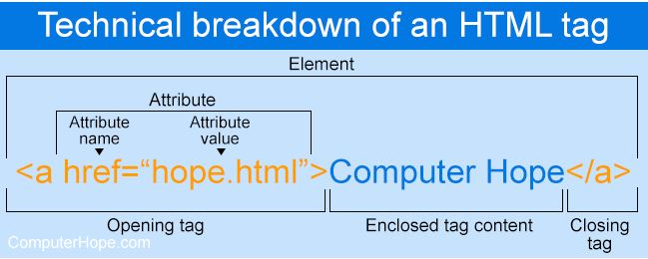

Each tag is contained between [less than](https://www.computerhope.com/jargon/l/lessthan.htm) and [greater than](https://www.computerhope.com/jargon/g/greathan.htm) angle brackets, and everything between the opening and closing tag is displayed or affected by the tag. In the example above, the [<a>](https://www.computerhope.com/jargon/h/html-a-tag.htm) tag creates a link called "Computer Hope," pointing to the hope.html file.

For tags with no closing tag, like the [<img>](https://www.computerhope.com/jargon/h/html-img-tag.htm) tag, it's best practice to end the tag with a forward slash, as shown below.

<img src="https://www.example.com/logo.gif"/>

**Main Starting Tags in HTML**

<!DOCTYPE html>

<html>

<head>

<title> The Title of the Web Page</title>

</head>

<body>

</body>

</html>

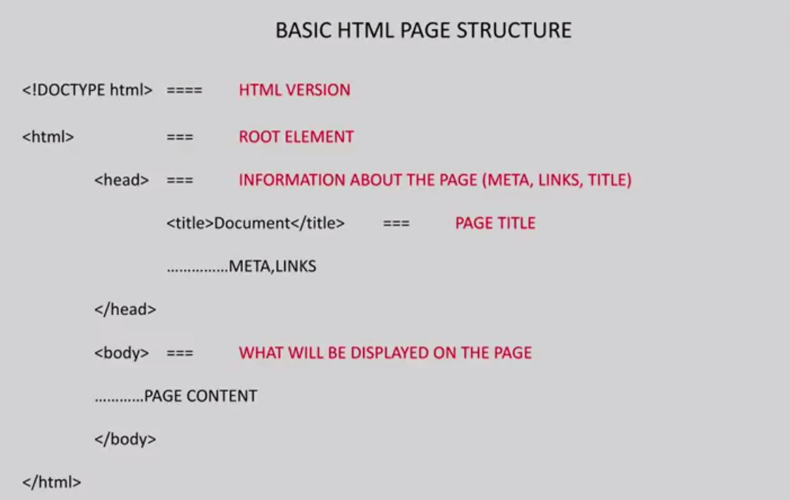

**<!DOCTYPE>:** It defines the document type or it instruct the browser about the version of HTML.

**<html >** :This tag informs the browser that it is an HTML document. Text between html tag describes the web document. It is a container for all other elements of HTML except <!DOCTYPE>

**<head>:** It should be the first element inside the <html> element, which contains the metadata(information about the document). It must be closed before the body tag opens.

**<title>:** As its name suggested, it is used to add title of that HTML page which appears at the top of the browser window. It must be placed inside the head tag and should close immediately. (Optional)

**<body>**: Text between body tag describes the body content of the page that is visible to the end user. This tag contains the main content of the HTML document.

**What is an attribute?**

Elements in HTML have **attributes**; these are additional values that configure the elements or adjust their behavior in various ways to meet the criteria the users want.

Attributes define additional characteristics or properties of the element such as width and height of an image. Attributes are always specified in the start tag (or opening tag) and usually consists of name/value pairs like name="value". Attribute values should always be enclosed in quotation marks.

Also, some attributes are required for certain elements. For instance, an <img> tag must contain a src and alt attributes.

# HTML Attribute

* HTML attributes are special words which provide additional information about the elements or attributes are the modifier of the HTML element.
* Each element or tag can have attributes, which defines the behavior of that element.
* Attributes should always be applied with start tag.
* The Attribute should always be applied with its name and value pair.
* The Attributes name and values are case sensitive, and it is recommended by W3C that it should be written in Lowercase only.
* You can add multiple attributes in one HTML element, but need to give space between two attributes.

**Image in html**

The <img> tag is used to embed an image in an HTML page.

Images are not technically inserted into a web page; images are linked to web pages. The <img> tag creates a holding space for the referenced image.

The <img> tag has two required attributes:

* src - Specifies the path to the image
* alt - Specifies an alternate text for the image, if the image for some reason cannot be displayed

**Note:** Also, always specify the width and height of an image. If width and height are not specified, the page might flicker while the image loads.

## [What is a link?](https://developer.mozilla.org/en-US/docs/Learn/HTML/Tables/Basics#what_is_a_table)

The **<link> tag** in HTML is used to define a link between a document and an external resource. The link tag is mainly used to link to external style sheets. This element can appear multiple times but it goes only in the head section. The link element is empty, it contains attributes only. The values in the link element denote how the item being linked to & is related to the containing document.

**video**

The <video> tag is used to embed video content in a document, such as a movie clip or other video streams.

The <video> tag contains one or more [<source>](https://www.w3schools.com/tags/tag_source.asp) tags with different video sources. The browser will choose the first source it supports.

The text between the <video> and </video> tags will only be displayed in browsers that do not support the <video> element.

There are three supported video formats in HTML: MP4, WebM, and OGG.

## [What is a Table?](https://developer.mozilla.org/en-US/docs/Learn/HTML/Tables/Basics#what_is_a_table)

A table is a structured set of data made up of rows and columns (**tabular data**). A table allows you to quickly and easily look up values that indicate some kind of connection between different types of data, for example a person and their age, or a day of the week, or the timetable for a local swimming pool.

## [What is a list?](https://developer.mozilla.org/en-US/docs/Learn/HTML/Tables/Basics#what_is_a_table)

HTML offers web authors three ways for specifying lists of information. All lists must contain one or more list elements. Lists may contain −

* **<ul>** − An unordered list. This will list items using plain bullets.
* **<ol>** − An ordered list. This will use different schemes of numbers to list your items.
* **<dl>** − A definition list. This arranges your items in the same way as they are arranged in a dictionary.

**Block and inline**

Every HTML element has a default display value, depending on what type of element it is.

There are two display values: block and inline.

## Block-level Elements

A block-level element always starts on a new line, and the browsers automatically add some space (a margin) before and after the element.

A block-level element always takes up the full width available (stretches out to the left and right as far as it can).

Two commonly used block elements are: <p> and <div>.

The <p> element defines a paragraph in an HTML document.

The <div> element defines a division or a section in an HTML document.

## Inline Elements

An inline element does not start on a new line.

An inline element only takes up as much width as necessary.

This is a <span> element inside a paragraph.

# HTML Form

An HTML form is used to collect user input. The user input is most often sent to a server for processing.